COURSE: CLOUD AND NETWORK SECURITY _C1-2024
STUDENT NAME: LENNIE NTHIGA
STUDENT NO: cs-cns07-24170
November 14,2024

WEEK 8 ASSIGNMENT 1
Assignment 1: Azure Firewall

Introduction
This exercise would be demonstrating examples of measures of restrictions , guidelines and security on a network/virtual machines resources .Here we would be restricting the access of the virtual machine to bowser bing.com website in certain ports. Implementing a firewall that would be protecting the workload server where the users would be accessing some resources.
We would be initializing two virtual networks one jump and work virtual machines for the purpose of the jump to be the one accessible to any user given the credentials to it but masking the work virtual machine which could be used to store sensitive data and resources
The labs activity
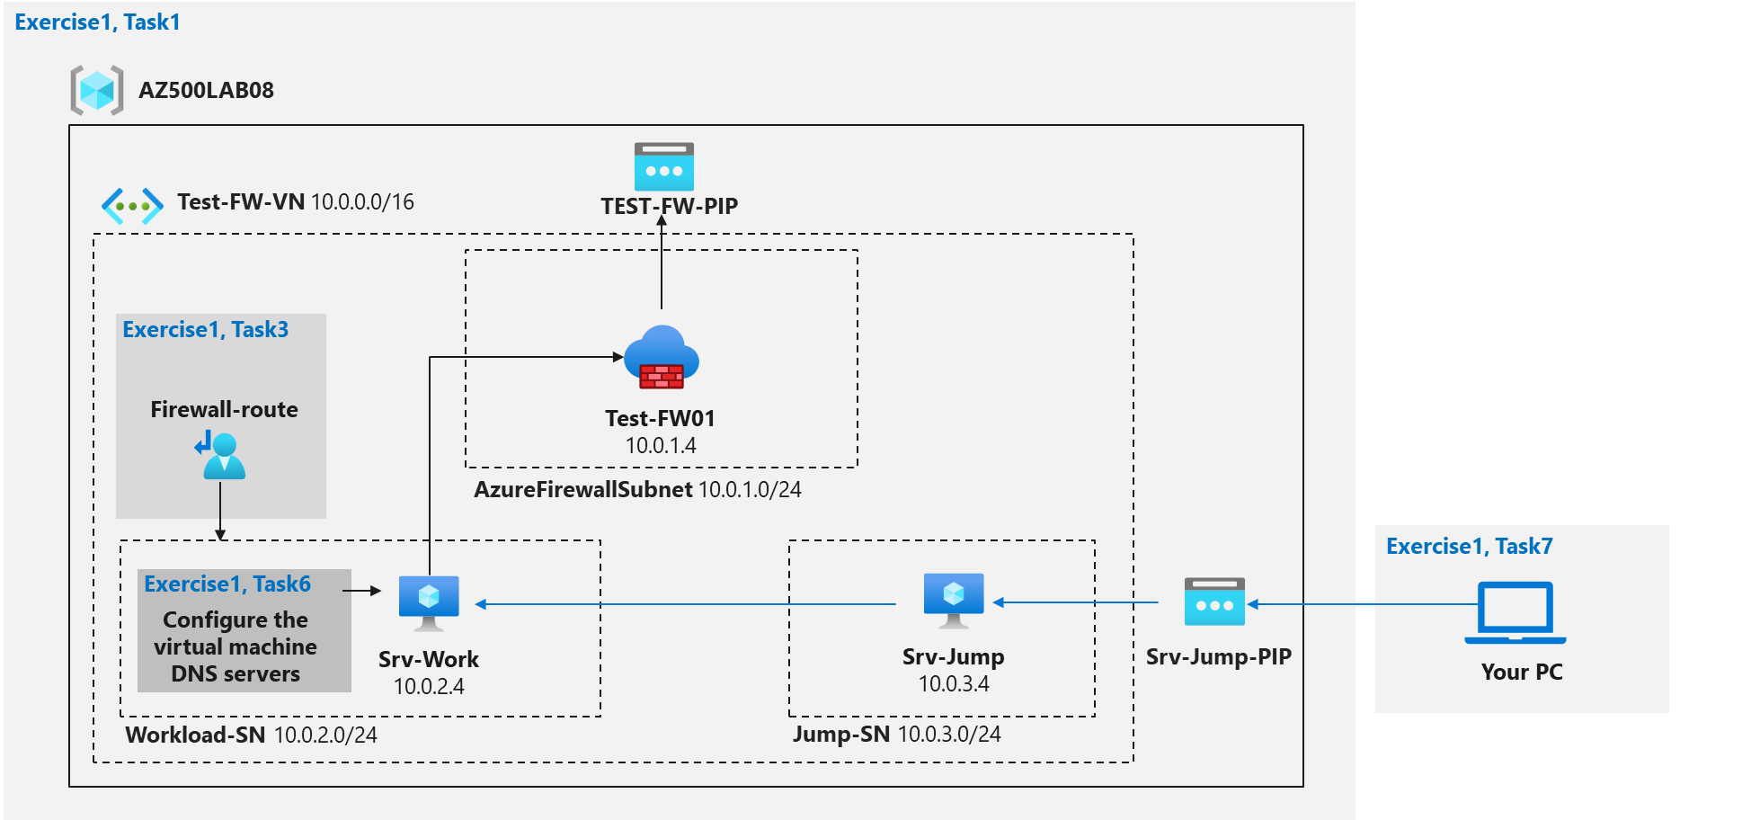

Step 1: Deploy and test an Azure Firewall

Task 1: deploying the template to the lab environment.
Which would load and configure some of the require resources in a newly created resources group name AZ500LAB08
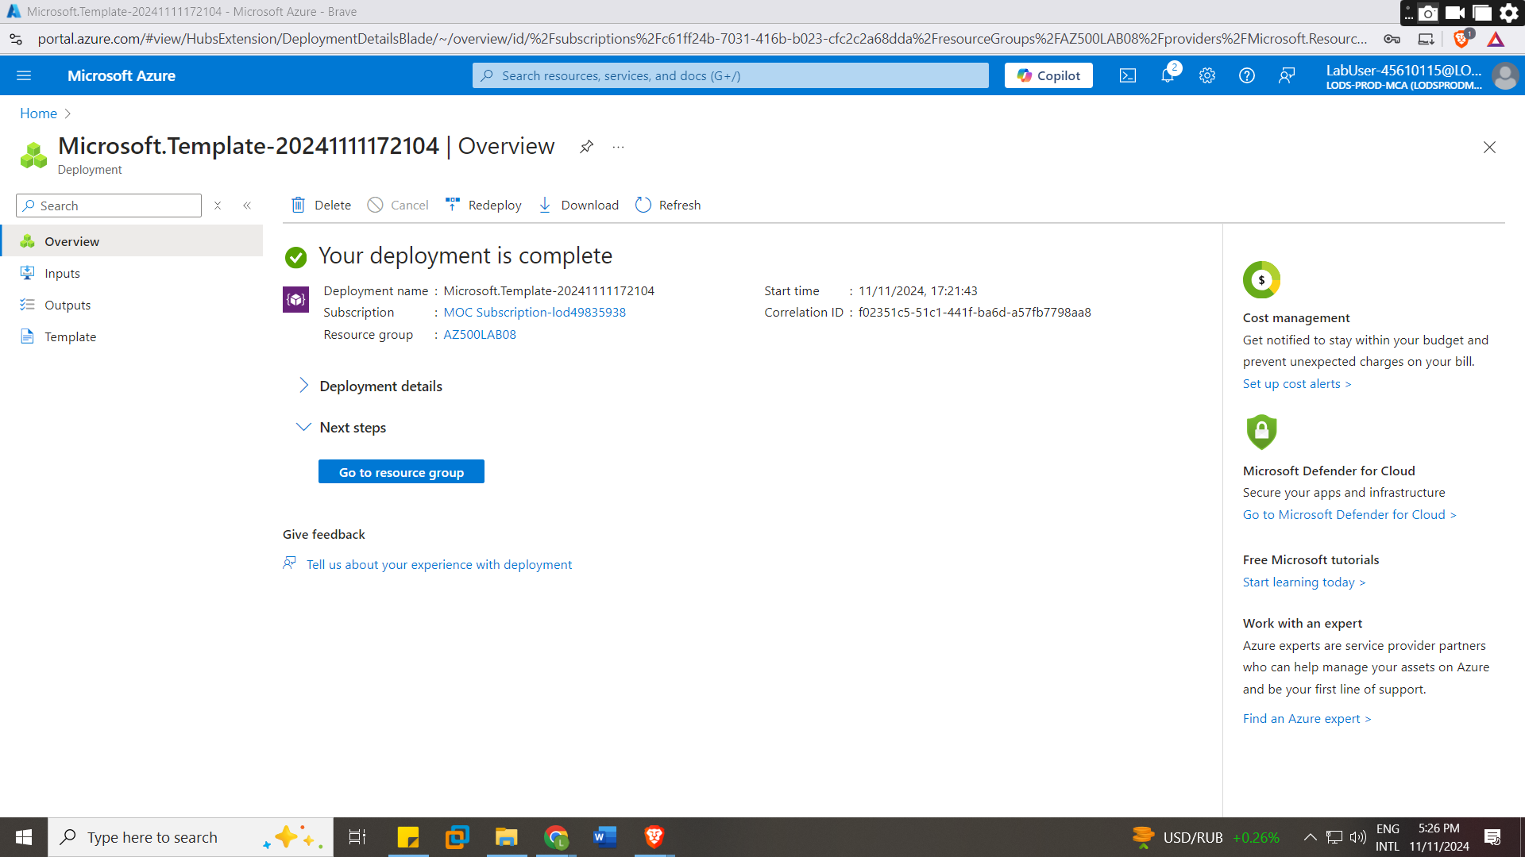
Task 2: Deploy the Azure firewall
By searching for the firewall in the azure we would create a new firewall an configure it under the resource group we created with configurations
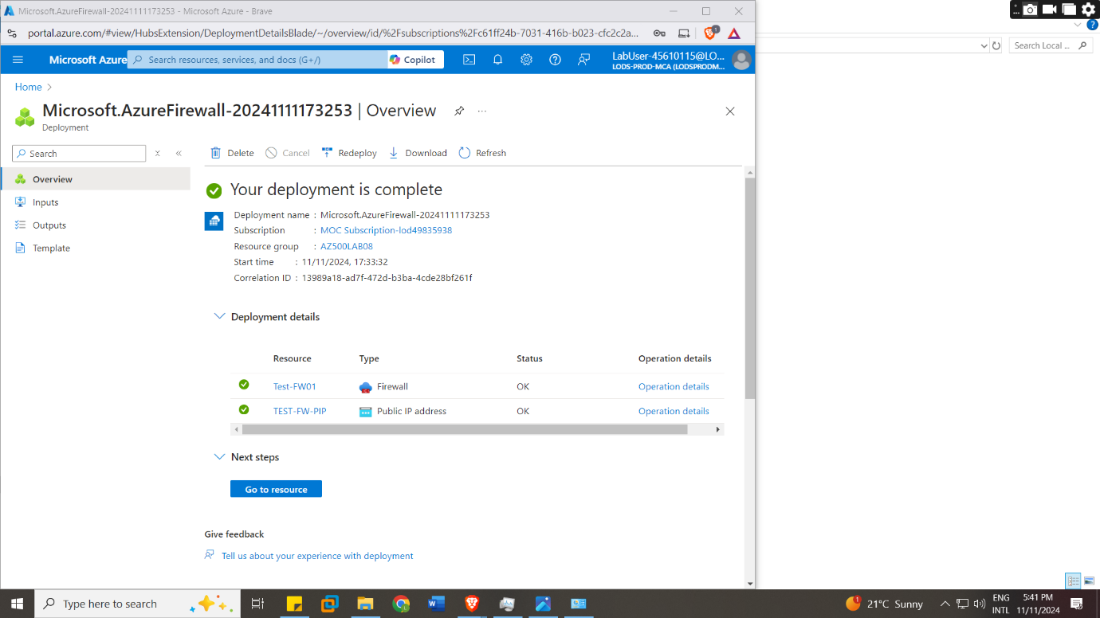

Task 3: Create a default route
We would create a default route for the cases of a packet Is sent/request and there’s no route taking effect for that requests IPS destination .in this case we configured the outbound traffic tough the firewall to the workload-subnets

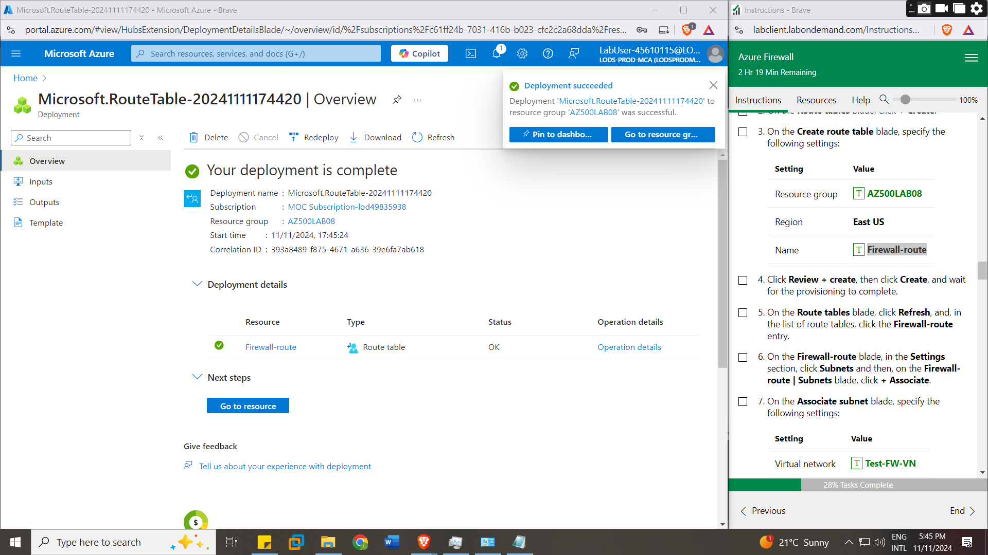

Task 4: Configure an application rule
The application rule is to controls access to specific applications and services by filtering traffic based on the application layer by allowing and denying some services
Priority values range from 100(highest priority) to 65000(lowest priority)
We gave a permission to the access of www.bing.com to use http and https for the network in subnets 10.0.2.0/24 devices that is the workload-sub
Task 5: Configure a network rule
Network rule would define the regulations on the network in the lab
Here we set the DNS server IPs to be 209.244.0.3 and 209.244.0.4
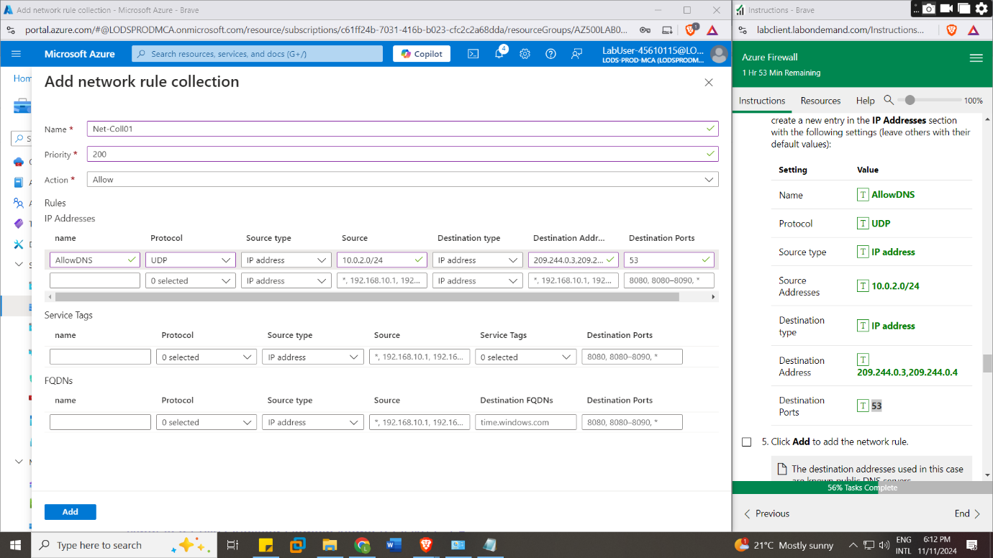

Task 7: Test the firewall
First we downloaded the RDP file from the and run it which upon the submission of the password it would open the Srv-Jump virtual machine from which is connected to the Srv-Work virtual machine which would be access by running command mstsc /v:Srv-Work in the run dialog
Srv -jump
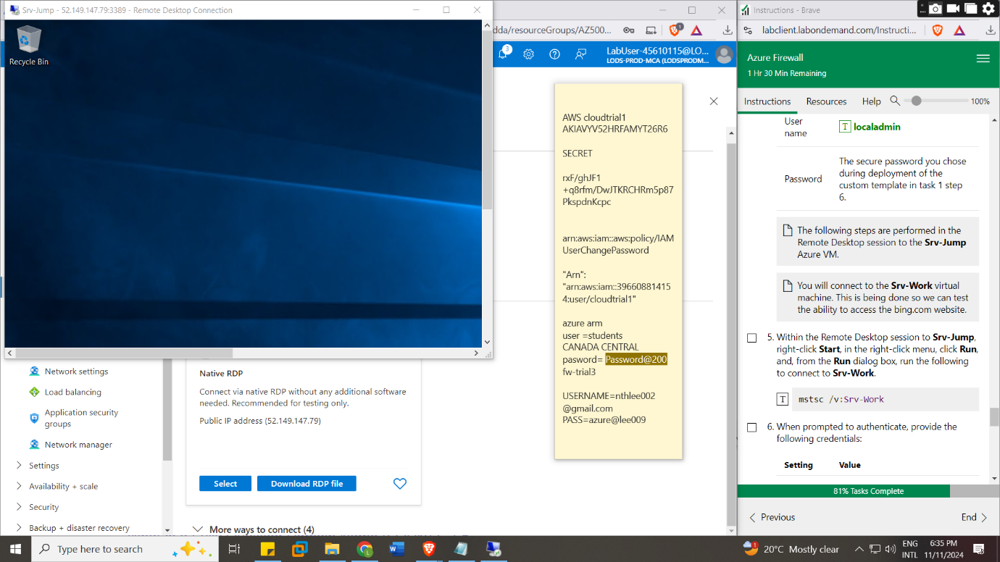

Accessing srv-work
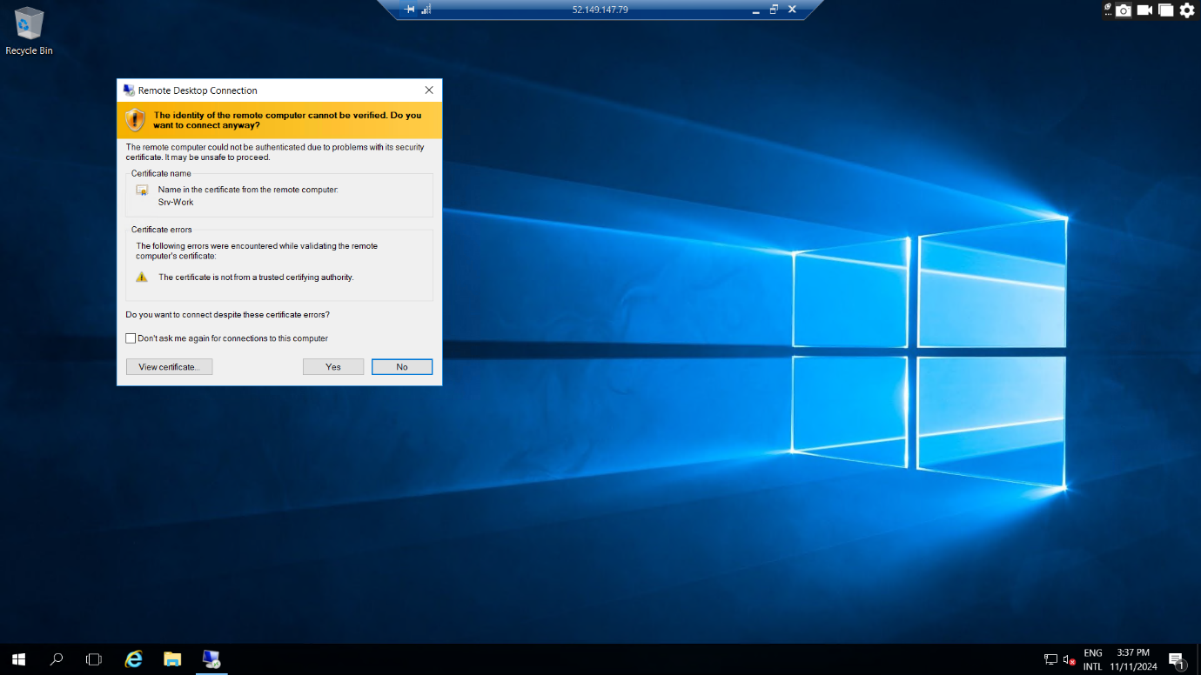

Srv-work

Thereafter would access the server manager and turn off the IE Enhanced Security Configuration to prevent imitations to the browser
Thus, by searching https://www.bing.com the browser was functional however upon browsing Microsoft it was brin up an error this proving that the application rule of accessing certain website worked

In the end the resources would be deleted to reduce costs

Conclusion
The firewall creation has shown that there are many more features that can be used for security purposes and prevention wise . In that we can use the firewall to block certain websites to avoid the user of the virtual machines from freely using the resources in the virtual machines which can bring to the injecting of malwares in the system o reduce the productivity of the users .

